Hello 👋

Just reacting out in anticipation for the up-and-coming Country Week season.

Every year at Grill'd Carousel we host numerous schools from our rural communities and this year we wanted to reach out to get ahead of the rush and help with any questions you may have.

Below we've provided a link for you to place booking from groups of 5 to 40.

[https://obee.com.au/grilld/carousel/](https://aus01.safelinks.protection.outlook.com/?url=https%3A%2F%2Fobee.com.au%2Fgrilld%2Fcarousel%2F&data=05%7C02%7Cpeter.r.smith%40education.wa.edu.au%7Ca0bf708c3fd549e0a7fe08dd5f997773%7Ce08016f9d1fd4cbb83b0b76eb4361627%7C0%7C0%7C638771834972534696%7CUnknown%7CTWFpbGZsb3d8eyJFbXB0eU1hcGkiOnRydWUsIlYiOiIwLjAuMDAwMCIsIlAiOiJXaW4zMiIsIkFOIjoiTWFpbCIsIldUIjoyfQ%3D%3D%7C0%7C%7C%7C&sdata=O2kknHU6P9gyDzucWlBwMEhpyCOjpsL%2BoL9DNnNlnN4%3D&reserved=0)

If you need a larger booking or have already booked, please email us directly so we can accurate numbers for your booking.

We are located on the top level of Westfield Carousel Shopping centre and are uniquely equipped to serve large groups to dine in. We also have a movie ticket deal as an option with your booking or catering order, so just let us know if you're interested in that also. 🎬

Our most popular option by far is the Dynamic Cheeseburger series priced at 14.50 per person which comes with a Burger and Chips. We know it's really hard to find something that is health and fresh to suit everyone, but we are your one stop shop at Grill'd Carousel for Healthy Burgers done right 😊

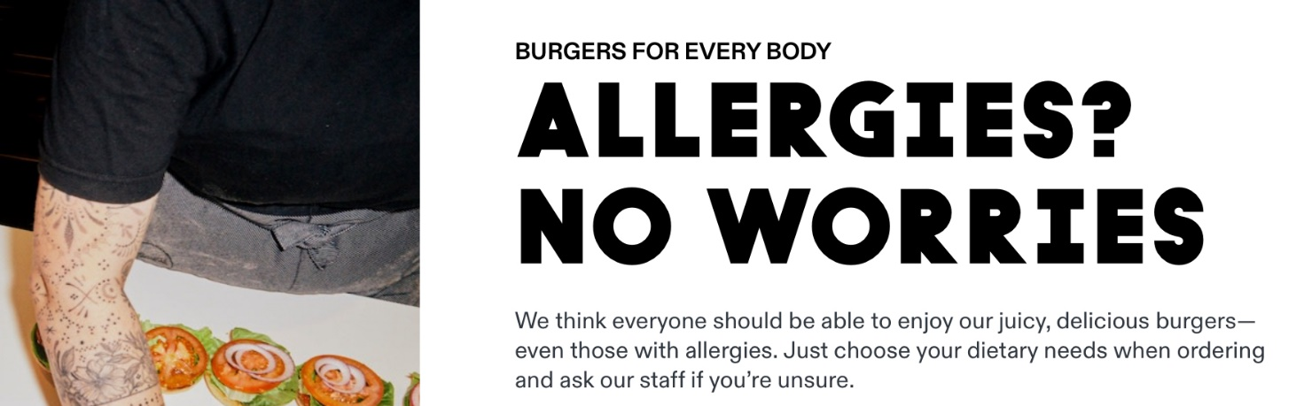

Warm regards,

**Dion Chiarenza|**Restaurant Manager**|**GRILL’D Carousel

Grill’d *Healthy Burgers - 100% Natural*

*E:dion.Chiarenza@grilld.com.au -* M:0402006416