COUNTRY WEEK CATERING ORDER FORM
Please fill in this form and send to SubwayWembley@gmail.com. Once received, we will call you to confirm, then email you the invoice.
Please call 9285 8688 or 0466 491 608 (Azlan) for any enquiries. Thank you!
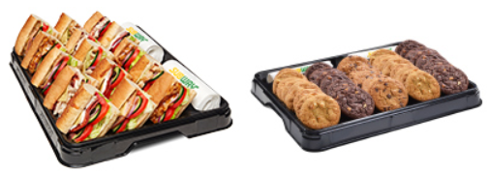
Contact Name
Mobile Number
School Name
Email Address
Date(s) of Pick up
Time(s) of Pick up
Special Dietary Requirements (vegetarian requests)

 | Quantity | Total
CLASSIC Platter -$56 (incl. Veggie Sub)  (5 Footlongs – 15 Portions)  (Ham, Turkey, Italian BMT, Chicken Strips, Veggie) |  | $
FAVOURITE Platter - $60 (all meat Subs)  (5 Footlongs - 15 Portions)  (Ham, Turkey, Italian BMT, Chicken Strips x2) |  | $
Cookie Platter –$30  (36 Assorted Cookies) |  | $
 | Grand Total: | $

